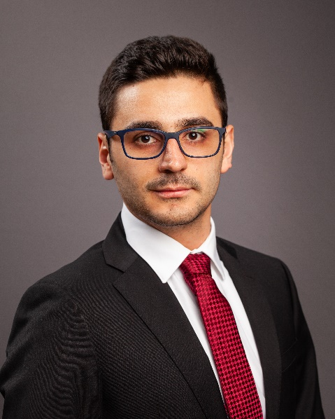
Name: Andres Miguel Biondi Vaccariello
Phone number: 617-982-9678
Email: Andres_biondivaccariello@student.uml.edu
Andres Biondi grew up in Venezuela and graduated from U.E Maria de Lourdes Perera high school receiving the seniors of the year award. Andres moved the United States to pursue his dream to become an Engineering. He graduated from Eastern Nazarene College with a Bachelor of Science in Physics and a minor in Engineering. While pursuing his undergraduate studies he was part of the varsity tennis team, president of the Shrader club and received the Senior Scholar Athlete of the year, ITA Scholar- Athlete, and the Outstanding Senior Award. Prior joining University of Massachusetts Lowell as PhD student, he worked as Lab manager and Teaching Assistant for freshman Astronomy class. Andres primary research interested covers a broad range of fiber optics sensing techniques and optical sensors. His current work is based on Distributed Fiber Optics sensors for Structural Health Monitoring. After graduation, Andres plans to spend time in the aerospace industry sector, before returning to work in academia.

