Standard Operating Procedures for consultant Resource IDs
- Consultants should send both shapefiles and MicroStation DGN files of resources identified.
- VTrans CADD Guidance link
  - https://vtrans.vermont.gov/cadd
  - Standards and Procedure Manual: VAOT Computer Aided Design & Drafting Introduction (vermont.gov)
- Use the Legend Sheet below, they can reference and then use for all the line styles and levels.
  - For those who can see the T: it is at T:\CADD\WorkSpace\Projects\English\dgn\forms\LegendSheet.Dgn
- Below are some recommendations from the VTrans Design Section.
  - VTrans CADD Standards and Procedure Manual (https://outside.vermont.gov/agency/vtrans/external/CADD/WebFiles/Downloads/Standards/VAOT_cspm_2014.pdf), specific attention to section 6 (pages 27 (PDF #33) to 37 (PDF #43)) and Appendix D (PDF pages 103 to 109), and the Plan Set Symbology Legend (Found on the CADD Help, Details & Examples webpage: https://vtrans.vermont.gov/cadd/downloads/details). Environmental Permit Symbology Legend, open LegendSheetEnv.dgn.
- Other
  - Be sure you are using Vermont State Plane Grid (Linear Units = U.S. Survey Foot).
  - Be sure you are using VTrans standard line styles for Arch, Historic, 4f, wetlands, etc. See example below.
    - 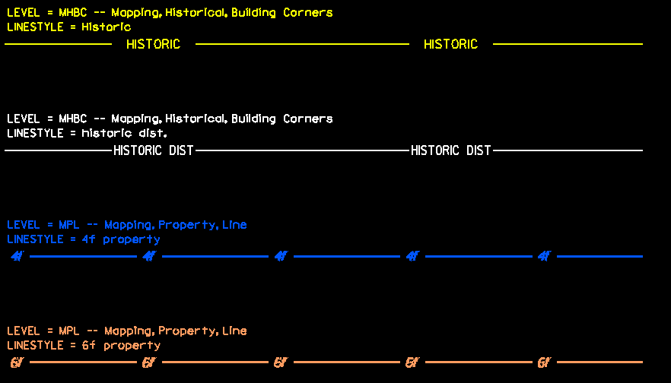
    - All environmental symbols and line styles can be found here:
      - Environmental Permit Symbology Legend, open LegendSheetEnv.dgn. https://vtrans.vermont.gov/cadd/downloads/details (mentioned in #4 above)
      - All text should match levels if additional text is required.
  - Historic and 4f
    - Historic Buildings have the (H) symbol in/on them in the drawing. Each building with an (H) is a specific historic building, no need to also outline the building.
    - If the property is historic, put the –Historic— line around the property’s parcel boundary line. This is specific to individual properties that are not related to historic districts, see below.
    - Historic Districts will be outlined or at least have some limit lines even if not a closed shape.
      - Contributing historic properties within the district will be noted with the historic (H) symbol and non-contributing properties will have no symbology. Do not outline contributing parcels within the district with the historic line as this will result in too many lines (this also applies to parcels within a historic district that may be considered individually eligible as well as being contributing).
    - Non-historic properties do not have symbology. Do not add property lines or point features as these are shown in other ways through the VTrans survey drawings and ROW parcel lines.
    - Use the 4f line style for all 4f property types other than historic. Historic properties are identified only by the historic line style and are understood to also be 4f properties.
  - Archaeology:
    - Archaeologically sensitive areas will be identified with –ARCH- line style surrounding the sensitive area.
    - If the area is a large field, then one may not need to close the shape but the line should extend along the sensitive limits on the roadway side and face INTO the arch sensitive area.
      - Example:
    - -ARCH- lines are to be used to show both Pre-Contact (Native American) archaeological sensitivity as well as Historic archaeological sensitivity such as mill remains, structure remains, or other features that show above ground but are considered archaeological in nature.
  - Be sure you are using VTrans Agency Seed File: "T:\CADD\WorkSpace\Projects\English\seed\vtseed3d.dgn"
  - Most likely any conversion being done from Meters to feet should not be done. Simply create the DGN files in metric units then change the display units of the file. A conversion issue often happens when converting file formats because AutoCAD and MicroStation handle units differently and many applications assume the AutoCAD method.
  - Only include the specific resource graphics. Do not include ROW lines, property parcel lines, survey, etc.
    - Extra info will be duplicated by VTrans designers and will cause issues.
- File naming convention
  - w"project PIN"rsc.dgn (if multiple dgn files, w"projectPIN"rsc_"resource".dgn). Example: w12D025rsc_Historic.dgn
- Current Connect Edition Workspace download.
  - https://outside.vermont.gov/agency/VTRANS/external/CADD/WebFiles/Downloads/VTrans_ConnectEditionWorkspace.zip
- old V8i Workspace Download
  - https://outside.vermont.gov/agency/vtrans/external/CADD/WebFiles/zip/workSpaceResources/VTrans2016March28setV8i.zip
- Conventional Legend Symbology Sheet
  - https://outside.vermont.gov/agency/vtrans/external/CADD/WebFiles/pdf/LegendSheet.pdf
  - https://outside.vermont.gov/agency/vtrans/external/CADD/WebFiles/dgn/form/LegendSheet.dgn
- Environmental Permit Legend Sheet
  - https://outside.vermont.gov/agency/vtrans/external/CADD/WebFiles/dgn/form/LegendSheet_EnviromentalPermits.pdf
  - https://outside.vermont.gov/agency/vtrans/external/CADD/WebFiles/dgn/form/LegendSheet_EnviromentalPermits.dgn

