FOR PUBLIC DISTRIBUTION:
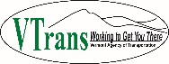
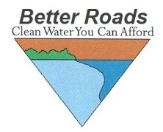

FY2018 Vermont Better Roads Grant Program
Due by 5pm on Friday March 17th, 2017
The Vermont Agency of Transportation is pleased to announce the 20th year of funding to support projects on municipal roads that improve water quality and result in maintenance cost savings. The grant funds are provided by the VT Agency of Transportation. The Vermont Better Roads Program’s goal is to promote the use of erosion control and maintenance techniques that save money while protecting and enhancing Vermont’s lakes and streams. Funds, subject to availability, will be distributed as grants to municipalities to address town erosion problems.

Please contact coordinators Alan May at (802) 828-4585/alan.may@vermont.gov or Linda Blasch at (802) 498-7216/linda.blasch@vermont.gov if you have any questions.
This application may be downloaded at the following address: http://vtrans.vermont.gov/highway/better-roads

