FOR PUBLIC DISTRIBUTION:
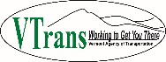
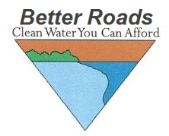

SFY2025 Vermont Better Roads Grant Program

October 19, 2023
The Vermont Agency of Transportation is pleased to announce the 27th year of funding to support projects on municipal roads that improve water quality and result in maintenance cost savings. The grant funds are provided by the VT Agency of Transportation with partnership through the Vermont Agency of Natural Resources. The Vermont Better Roads Program promotes the use of erosion control and maintenance techniques that save money while protecting and enhancing water quality around the State.
Please note that the application scoring of the Better Roads Program is intended to be in line with the State’s Clean Water Act (Act 64), as well as the Municipal Roads General Permit (MRGP). In an effort to prioritize funding for projects that are providing significant water quality improvements, applicants must indicate whether or not the projects that they intend to construct will be in full compliance with the MRGP. Please see application and scoring sheet for more information. If you have questions, please feel free to contact Better Roads staff.
Applications for funding will be accepted until December 20th, 2023.
For the most up-to-date information or to download a copy of the application please visit our website at: http://vtrans.vermont.gov/highway/better-roads

For Project and Program Technical Information please contact:
Alan May
(802)828-4585 or via email alan.may@vermont.gov

For Funding or General Program Questions, please contact:
Ross Gouin
(802)595-2381 or via email: ross.gouin@vermont.gov

