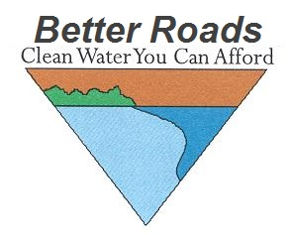

Better Roads Grant Program: Municipal Invoicing Spreadsheet
Please attach: Copies of invoices and receipts for all expenses documented below
If Category B, C, or D, then 4 pictures (2 During, 2 After project is completed)

TOWN: _____________________________________ CONTACT NAME: _________________________________

TOWN HIGHWAY NAME: _____________________ EMAIL: ___________________________________________

GRANT AGREEMENT NUMBER: BR____________ PHONE NUMBER: _________________________________

GRANT AWARD: $___________________________

Fill out sections below which apply to your project, use additional pages if needed.

LABOR (Employee Name) | Date Range | Rate | # Hours | Total (Hourly Rate x Hours)
 |  |  | LABOR TOTAL

EQUIPMENT | Date Range | Rate | # Hours (or Days) | Total (Rate x Hours)
 |  |  | EQUIPMENT TOTAL

MATERIALS | Rate | Amount | Total (Rate x Amount)
 |  | MATERIALS TOTAL

MISCELLANEOUS | Rate | Amount | Total (Rate x Amount)
 |  | MISCELLANEOUS TOTAL

GRAND TOTAL $______________________

LOCAL MATCH $__________________________

LOCAL MATCH is the GRAND TOTAL minus GRANT AWARD.
LOCAL MATCH must be at least 20% of the GRAND TOTAL to receive full amount of GRANT AWARD. If LOCAL MATCH is less than 20% of GRAND TOTAL, your grant reimbursement will be reduced.

By signing this application, I certify that all the information provided is accurate, to the best of my knowledge.

We have complied with all the requirements of this grant award including; a commitment to the future maintenance of this grant funded work and repair as necessary. We will make our books available for audit if required.

Please check one: Progress payment ______ Final payment ______

Signature: _________________________________ Title: ______________________________________________
(Must be Selectboard Chair, Town Clerk, or Administrator)

Required attachments: Copies of invoices and receipts for all expenses documented
If Category A, provide a copy of your Report and Capital Budget (as applicable)
If Category B, C, or D, then 4 pictures (2 During, 2 After project is completed

Please submit to: Better Roads Program
Agency of Transportation, Municipal Assistance Bureau

Via Email to:

BetterRoads@vermont.gov

