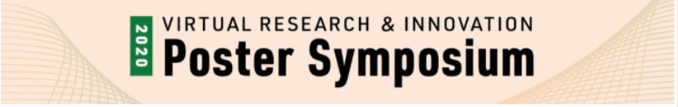

Questions, Comments and Responses

Bridge-Stream Network Assessments to Identify Sensitive Structural and Hydraulic Parameters for Planning Flood Mitigation

Rachel Seigel, Rachel.Seigel@uvm.edu

Q1. How are you calibrating and validating each 2D HEC-RAS model?

A1. The models use observed hydrograph data collected from USGS stream gauges to calibrate to storm events like Tropical Storm Irene. The models are then validated using high water marks and comparing the modeled data to the observed data using a Nash-Sutcliffe Efficiency value.

Q2. What consideration for debris potential is there along a reach of river when evaluating the water power at a bridge or culvert?

A2. For a 2D HEC-RAS model there is potential for modeling sediment flow. For this work we are widening and shortening cross sections around bridges and culverts to change flow scenarios. It is possible to create culverts and constrict the opening to potentially simulate debris, however there is nothing specific in HEC-RAS that I am aware of that would model debris.

Q3. How is this useful for maintaining current infrastructure and stakeholders?

A3. This research will help us identify specific sensitivities with each structure in the bridge-stream network. By finding similarities across all three models we can determine which type of structures and river features are more sensitive to change or a specific flood parameter. Stakeholders can use this information to help adjust current and future projects.

