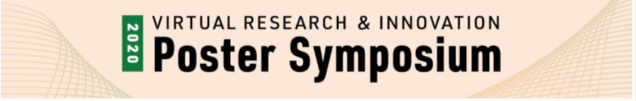

Questions, Comments and Responses

Ranking Transportation Structures in Vermont by their Potential to Facilitate Wildlife Passage: A Connectivity Modeling Approach

Caitlin Drasher | cdrasher@uvm.edu

Dr. James Murdoch | jmurdoch@uvm.edu

Q1. Are there ways to combine the landscape analysis and the structure analysis to create a single set of rankings for transportation structures?

A1. Our goal is to develop a single rank for each transportation structure, by using the both the landscape-scale and structure-scale to inform the final ranking. For example, a structure may have great habitat surrounding it at the structure scale that would promote white-tailed deer crossings. However, this structure may not be located in an area of the landscape where deer normally travel. It is important to take both scales into account for this ranking.

One way to do this involves multiplying the outputs from the landscape-scale by the outputs for the structure-scale. Another method involves using the current density output from the landscape scale as a source-strength input for the structure scale. We will ultimately explore and compare four different approaches to find the most comprehensive ranking.

Q2. Are there any benefits of the project to other agencies/organizations in Vermont?

A2. Yes, this connectivity analysis covers the entire state of Vermont – not just areas surrounding roads. The maps produced from our statewide analysis can highlight locations that are important for landscape connectivity for each focal species. This is useful for both wildlife and land management agencies, when deciding which parcels to conserve and/or manage for a particular species. The Vermont Fish & Wildlife Department, The Nature Conservancy, and the Staying Connected Initiative are all groups that are working toward increasing landscape connectivity for wildlife in our state.

Q3. What species have you documented using transportation structures, and are there any structure characteristics that might help facilitate passage?

A3. There have been many species detected using transportation structures in Vermont. Some mammals detected include black bear, bobcat, coyote, deer, fisher, grey and red fox, moose, otter, skunk, and small weasels. Based on an earlier phase of this project that analyzed camera data, larger structures (bridge spans and spans with footing shelves) were frequently used for a variety of species. Pipe culverts facilitated movement of primarily smaller species. Bobcats have been seen using footing shelves in smaller structures. Additionally, structures that have vegetation surrounding the openings are thought to promote wildlife use by providing cover. These findings are summarized in a 2019 report by Paul Marangelo.

