FY2025 Vermont Better Roads Grant Program
Due by Wednesday December 20th, 2023
The Vermont Agency of Transportation is pleased to announce the 27th year of funding to support projects on municipal roads that improve water quality and result in maintenance cost savings. The grant funds are provided by the VT Agency of Transportation with partnership through the Vermont Agency of Natural Resources. The Vermont Better Roads Program promotes the use of erosion control and maintenance techniques that save money while protecting and enhancing water quality around the State.
Please note that the application scoring of the Better Roads Program is intended to be in line with the State’s Clean Water Act (Act 64), as well as the Municipal Roads General Permit (MRGP). In an effort to prioritize funding for projects that are providing significant water quality improvements, applicants must indicate whether or not the projects that they intend to construct will be in full compliance with the MRGP. Please see application and scoring sheet for more information. If you have questions, please feel free to contact Better Roads staff.

Better Roads funding may not be used as match for other state or federally funded programs.
This application may be downloaded at the following address: http://vtrans.vermont.gov/highway/better-roads

A. Road Erosion Inventory and/or BMP Implementation Planning
Category A applications are not currently being solicited for FY2025, but we anticipate updates on this soon.
VTrans is working on funding for this grant category along with other program details. We anticipate soliciting applications for Road Erosion Inventories / BMP Implementation planning, in advance of the 2024 field construction season. We will post an update as a stand- alone solicitation as soon as possible once funding is appropriated.
Categories B, C, and D – Current Solicitation
Projects may be enhancements of a scheduled project that provide additional erosion control benefits, such as ditch stabilization in conjunction with a culvert replacement, or may be a stand-alone erosion control solution. Project selection will be prioritized based on the selection criteria attached to this application.
B. Correction of a Road Related Erosion Problem and/or Stormwater Mitigation/Retrofit for both gravel and paved roads (Maximum Grant Amount $20,000)
Example projects:
♦ Stone or grass lined ditches
♦ Check dams, splash pools or other energy dissipaters
♦ Road-side rain gardens

♦ Small Culverts (<36”)
♦ Infiltration Practices
♦ Level spreader

♦ Stormwater infrastructure installation, rehab or replacement
♦ Catch basin outlet stabilization

C. Correction of a Stream Bank, Lake shore or Slope Related Problem (Maximum Grant Amount $40,000)
Example projects:
♦ Stream bank stabilization
♦ Slope stabilization, retaining walls
♦ Lake shore stabilization

D. Structure/culvert installation or replacement for culverts equal to or larger than 36” (Maximum Grant Amount $60,000)
Structures or culverts funded in this category must meet size requirements from a hydraulic study or from consultation with an Agency of Natural Resources River Management Engineer (for in-stream culverts). Additional erosion control work may be considered eligible as part of a project in this category but must be within a continuous work area of the 36” or larger culvert.

Example projects

♦ Box culvert or bridge
♦ Bottomless arch, round culvert or squash pipe larger than 36” in width
♦ Projects may also include other erosion control practices needed.

All work should be completed in accordance with specifications contained in the Vermont Better Roads Manual (https://vtrans.vermont.gov/sites/aot/files/highway/documents/ltf/Better%20Roads%20Manual%20Final%202019.pdf), or other applicable manual(s).
All awards will be subject to the terms and conditions set forth in our standard VTrans grant agreements including:
- Attachment C –Standard State Provisions for Contracts and Grants (12/15/2017) (link: Forms | Buildings and General Services (vermont.gov))
- Attachment D – Other Provisions
- Attachment E - DOT Standard Title VI Assurances and Non-Discrimination Provisions (DOT 1050.2A) - Assurance Appendix A and Assurance Appendix E
Please refer to our website at the following link for State and Federal requirements that will be included as part of these agreements. https://vtrans.vermont.gov/highway/better-roads
Supporting Documentation will enhance your application. You may acquire supporting documentation from an Agency of Natural Resources (ANR) River Management Engineer, ANR Lakes and Ponds Section staff, ANR Watershed Basin Planner, VTrans District Technical Staff, or Regional Planning Commission staff. See page 15 for contact information.
Permits – Towns are responsible for ensuring compliance with all applicable permits for their projects. If you have questions regarding what type of permit you might need or who to contact for a permit, please call one of the individuals on the contact list for assistance.

Applications must be received on or before Wednesday, December 20th, 2023.

Please send completed applications to:
Email: BetterRoads@vermont.gov
Phone: (802) 828-4585 (802) 595-2381

Emailed applications are required

The deadline to complete work for Categories B/C/D projects is September 30th, 2025. The deadline to submit final reports and invoices for these Category B,C,D grants will be December 30th, 2025.

The grant should represent a maximum of 80% of total project cost. A minimum 20% local match is required and can be met through cash expenditures as well as services such as staff and use of equipment (not funded by state or federal dollars). Final payment of grant award will be made upon submission and approval of invoices.
Municipalities may apply for more than one grant but are only eligible for the maximum grant amount of each category. For instance, a municipality could apply for two small Category B grants if the total of both grants is under the $20,000 maximum award. Additionally, a municipality could apply for both a Category B and a Category D project, etc.

Examples of how to calculate the required 20% match/requested grant amount:

Total Eligible Project Cost:
Category B- $25,000 Categories C- $50,000 Category D- $75,000

Maximum Grant Award:
Category B- $20,000 Categories C- $40,000 Category D- $60,000

Formula:
If Total Project Cost is more than the Total Eligible Project Cost, then
Match=Total Project Cost-Maximum Grant Award

If Total Project Cost is less than or equal to the Total Eligible Project Cost, then
Match=Total Project Cost x 0.2

Cover Sheet

Please complete this page ONCE and return with your Grant Category Application(s)
Town/Organization: ________________________
Primary Contact Person (Responsible for Signing Grant Agreement):_____________________ Title:___________________
Address: ______________________________________________________________________
Street Address Town Zip
Primary Contact Person Email: ____________________________ Phone: ( ) ______ - ___________
SAM unique ID #: ___________________ Fiscal Year End Month (MM):________
Town Clerk / Admin email: _____________________________________________________
Road Foreman Name:_______________________ Road Foreman Email:__________________________

CATEGORY B/C/D
Please complete one application per project you are applying for.
Please check the Category you are applying for:
- B. Correction of a Road Related Erosion Problem and/or Stormwater Mitigation
- C. Correction of a Stream Bank, Lake Shore or Slope Related Problem
- D. Structure/culvert 36” diameter or greater
Municipality: ___________________________________________________________________
Road Name: _________________________________TH #: ________ Structure # (if applicable): _______
Road Type: Paved or Unpaved (select one) Road Class: 1 2 3 4 (select one)
Please provide a thorough description of the erosion/water quality problem (ex. Roadway has steep slope with no ditch which is causing severe roadway erosion, which outlets into the Lamoille River): _________________________________________________________________________________________________________________________________________________________________________________________________________________________________________________________________________________________________________________________________________________________________________________________________________________________________________
Has the town completed an MRGP compliant road erosion inventory?
Yes No In progress

Project Length (linear feet along roadway): __________________ ft.
Number of structures/culverts replaced/repaired: _________________________
Average slope of roadway: 0-5% 5-10% >10%

Provide a VERY detailed map of project location showing start and end points: Included
Provide a sketch of project location showing distances and project details: Included

Please provide the Road Segment ID (RSID) for your project. If several, please list all. In addition to the RSID please indicate what the resulting rating of each segment before construction as well as after construction in accordance with the MRGP.* (i.e., Fully Meets Standard, Partially Meets, Does Not Meet) For assistance, please contact Better Roads Staff (802)828-4585.

 | Hydrologically Connected? |  | Pre-construction MRGP Conformance |  |  | Post-construction MRGP Conformance
RSID | Yes | No | Fully Meets | Partially Meets | Does Not Meet | Fully Meets | Partially Meets | Does Not Meet
*In order to “Fully Meet” the standards the road segment must have proper crown, removal of shoulder berms, proper ditching, proper conveyance and no erosion present at culvert inlets and outlets.
Environmental Concerns:
All projects require a review of potential impacts by our environmental team. To expedite the review process, please check the boxes below that describe existing structures/conditions to be replaced/maintained (if any) and the project description that applies (if any).

Existing Structures:
- Steel/Plastic Culvert | - Concrete Box Culvert
- Stone Culvert – Take pictures | - Concrete Bridge
- Ditch | - Rolled Beam/Plate Girder Bridge
- Foundation remains, mill ruins, stone walls, other – Take pictures | - Stone abutments or piers – Take pictures
- Buildings within 300 feet of work - Take pictures
Project Description:
- New ditches will be established | - All work will be completed from the existing road or shoulder
- Reestablishing existing ditches only | - There will be excavation within 300 feet or a river or stream – Take pictures
- The structure is being replaced on existing location/alignment | - Road reclaiming, reconstruction, or widening
- Excavation within a floodplain – Take pictures | - Temporary off-road access is required
- Tree cutting/clearing – Take pictures | - The roadway will be realigned

Please describe the project and how it will create a positive water quality benefit (ex. Reshape 500’ of ditch and line with 12 inch minus stone, to prevent sediment from entering the Lamoille River at the bottom of the hill):
_______________________________________________________________________________________________________________________________________________________________________________________________________________________________________________________________

Please list any professionals or partners that assisted with planning this project (ANR River Management Engineer, Army Corps of Engineers, VTrans staff, Basin Planner, RPC staff, etc.):
__________________________________________________________________________________________________________________________________________________________________________
Is the project located in the town “Right of Way? (select one) Yes No Both
Please be aware, Municipalities are required to have an Agreement for Entry & Liability Release for any impacted properties (prior to the start of construction.)

Budget:
Please attach a project budget and confirm below that is attached:
Project budget IS attached
Are you applying to other grant programs to help fund this project? If so, what programs? Please note that Better Roads requires a 20% local match and Better Roads funding may not be used as match for other state or federally funded programs.
_____________________________________________________________________________________
Requested Grant Amount Max:
Requested Grant Amount: $ __________.____ $20,000 Category B
+ $40,000 Category C
Local Match: $ __________.____ $60,000 Category D
=
See page 6 for more information on calculating match
Total Project Cost: $ __________.____

Estimated Completion Date: __________________
REQUIRED ATTACHMENTS:
Please use the documentation checklist below to ensure that all of the relevant items regarding your application have been included. It is preferred that your application is a single PDF file.
- Grant application cover sheet
- Grant application form, including chart with RSID and MRGP compliance before and after project completion
- Itemized Cost estimate for labor, equipment, and materials (see enclosed Cost Estimate Worksheet). If applicable, please break down funding by source (i.e. different grant sources).
- Detailed Project Location Map
- Sketch of proposed project and erosion control measures or other management practices, including distances in feet
  - Also show approximate location of town/other right-of-way and/or property lines and limits of work
- Photos must be color and clear to see.
  - Please make sure there are enough photos to get a good idea of the project area
- Other appropriate supporting documents.
By signing this application, I certify that all the information provided is accurate to the best of my knowledge. We will comply with all the requirements of the grant including making our books available for audit if required.
SIGNATURE OF APPLICANT:
Name:________________________________________________ Title:_________________________
MUST BE TOWN ADMINISTRATOR/MANAGER OR SELECT BOARD CHAIR
Vermont Better Roads Category B/C/D Grant Proposal Scoring Criteria

All applications will be scored on a sliding scale elected by the Better Roads Grant Selection Committee. Road BMP upgrades are considered the highest priority for grant funding when road segments are “hydrologically-connected,” currently “not meeting” MRGP standards, and road slopes are greater than 10%
- Is the project using Best Management Practices (BMPs) that are proven and likely to maximize long term success, such as practices contained within the new VTrans Better Roads Manual and/or VT DEC MRGP Standards?? [maximum 20 points]
- The proposed project utilizes appropriate BMPs and has maximized the likelihood of long-term success (16-20 points)
- The proposed project utilizes some appropriate BMPs but more could be done to increase the likelihood of success (11-15 points)
- The proposed project does not utilize appropriate BMPs, or it is unclear whether the BMPs will be used appropriately and the likelihood of success is uncertain (0-10 points)

- What are the expected Water Quality Benefits within the watershed? [maximum 25 points]
- Project will lead to significant improvements to water quality (21-25 points)
- Project will lead to moderate improvements to water quality (16-20 points)
- Project will lead to small improvements to water quality (1-15 points)
- Project will lead to no obvious improvements to water quality (0 points)

- Is the project in or does stormwater runoff from the project area drain into a hydrologically connected segment? [maximum 20 points]
- Yes; the entire project is in connected segment(s) (20 points)
- Partially; part(s) of the project are in connected segments (5-19 points)
- No; this project is not in a connected segment (0-5 points)

- Will the project result in full compliance of one or more segments in accordance with the Municipal Roads General Permit (MRGP)? [maximum 25 points]
- All segments within the project will be in full compliance (25 points)
- One or more segments will be in full compliance, with all other segments in partial compliance (11 – 24 points)
- One or more segments will be a minimum of partial compliance (1- 10 points)
- Project does not meet compliance or not applicable (does not have hydrologically connected segments) (0 points)

- Is the project cost effective? [maximum 10 points]
- The cost of the project is low and the expected benefits are high (8-10 points)
- The cost of the project is average and the expected benefits are average (5-7 points)
- The cost of the project is high and the expected benefits are low (0-4 points)

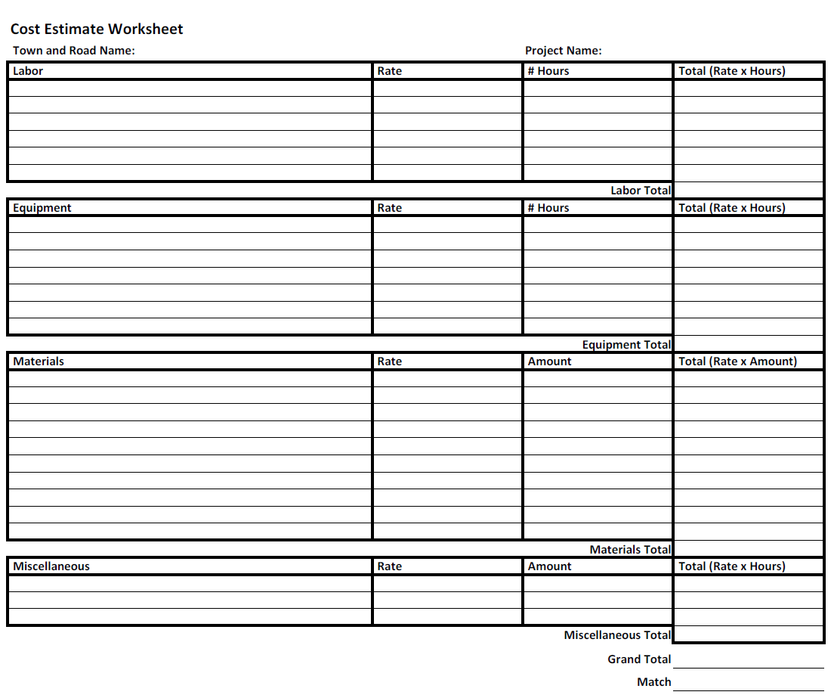

Questions and Technical Assistance
For questions regarding this application, general program related questions or for technical assistance please contact Alan May (802) 828-4585.
For questions related to projects affecting rivers and streams please contact the Agency of Natural Resources, River Management Engineers:
- Chris Brunelle, Northwest VT (802) 777-5328 or Chris.brunelle@vermont.gov
- Scott Jensen, Southeast VT (802) 490-6962 or Scott.jensen@vermont.gov
- Jaron Borg, Central VT & Northeast (802) 371-8342 or Jaron.borg@vermont.gov
- Josh Carvajal, Southwest VT (802)490-6163 or Joshua.carvajal@vermont.gov

For questions related to the Municipal Roads General Permit, please contact Evelyn Boardman, Municipal Roads Program Coordinator. (802) 636-7396 or Evelyn.boardman@vermont.gov

Project Completion Requirements
Categories B, C, and D
- Submit a Municipal Invoicing Spreadsheet (available on the Better Roads website): http://vtrans.vermont.gov/highway/better-roads).
- Four color photos of, during (2 photos) and after (2 photos) the project.
- Copies of invoices/receipts and time sheets to document expenses and local match.

River Management Engineer Support Letter

I am providing this letter of support to the Town/City/Village of ____________________________ for their Better Roads grant application on __________________________, which will have an impact on
Mile Marker, Road Name/TH Number
______________________________ .
Name of River/Stream

Stream Alteration Permit Required for this project: ☐ Yes ☐ No
Upon review of the site, I have determined that the proposed project is eligible for a Stream Alteration Permit. Additionally, if this project is constructed according to the recommendations described below (see Comments), the following stream equilibrium and connectivity benefits will be achieved:

☐ Restores or enhances floodplain/access to floodplain
☐ Restores or enhances natural channel dimensions
☐ Establishes tree/shrub buffer
☐ Restores habitat (including aquatic organism passage)
☐ No additional benefits
☐ Further restricts or impacts the stream

Thank you for your consideration,

Signature

Comments:

