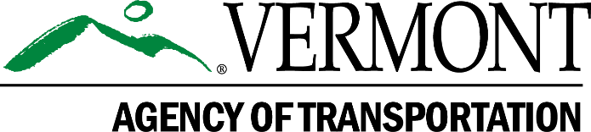
LVRT Community Grant Program
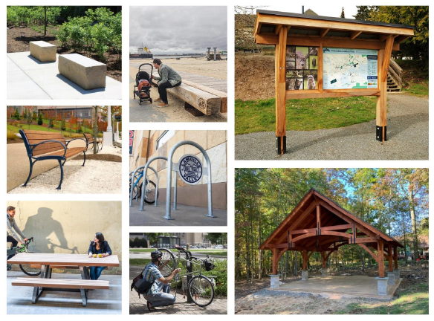Federal Aid Grant Program Guide

For additional Information, see the Program’s website at: https://vtrans.vermont.gov/highway/local-projects/lvrt/management

Application Deadline: November 1, 2022, 4:00 PM
Grant Program Overview
Introduction
The Vermont Agency of Transportation (VTrans) is pleased to provide grant funding for municipalities along the Lamoille Valley Rail Trail (LVRT) to improve trail amenities and visitor experience on the LVRT. As defined in the Senator Sanders Federal Earmark enabling legislation, the funding will be distributed as matching grants to communities along the trail to develop projects to improve its function as a means of transportation to the public. Projects may include, but are not limited to trail infrastructure, such as trailheads, picnic areas, kiosks, and connections to towns, signage and interpretive panel installation.

The purpose of this funding is to continue the build out and enhancement of LVRT trail amenities and visitor experience, in line with the priorities outlined in the recently completed LVRT Management Plan. Applicants are advised to review the LVRT Management Plan to guide development of project ideas and grant applications. The plan and supporting documents can be found at vtrans.vermont.gov/lvrt.

Eligible Applicants
Eligible applicants for this grant program are municipalities directly adjacent to the LVRT, including: St. Johnsbury, Danville, Cabot, Walden, Stannard, Greensboro, Hardwick, Wolcott, Morristown (Morrisville), Hyde Park, Johnson, Cambridge (Jeffersonville), Fletcher, Bakersfield, Fairfield, Sheldon, Highgate, and Swanton. Municipalities may apply as a consortium and are encouraged to work with their Regional Planning Commission (RPC) in refining project ideas. Appropriate consortium projects could include design or fabrication projects that would benefit from economy of scale and consistent production from a single vendor, such as signage, kiosks or other amenities. RPC applications must be structured as a consortium application with one town as the lead, the RPC as MPM and agreements between the towns on providing the match.

Eligible Projects
VTrans has identified the following as potentially eligible project types:
- Water and sewer connection for critical trailside amenities including bathroom facilities and water fountains
- Trail, sidewalk, or bike lane connections between trails or to downtowns, villages, and community assets such as existing parks or recreation fields
- Establishing or improving trail parking and trailheads
- Installing amenities such as benches, signs, pavilions, and kiosks
- Art installations
- Historic, cultural, and/or significant natural features signage, interpretive panels, or markers
- Supporting safety improvements (i.e. improving lighting, establishing a trail monitoring program)

Project Types
Scoping Studies -Scoping Studies look at different alternatives, assess right-of-way and environmental impacts, and develop realistic cost estimates associated with a prospective project. Scoping Studies help define projects, generate public support, and provide more confidence that a project will be successfully completed. A Scoping Study may be used to apply for subsequent rounds of design and construction funding.
Design/Construction Projects - Projects applied for under this category will move a concept through the design, permitting and right-of-way process to advance to construction. The LVRT Community Grant Program does not fund design only projects. Eligible costs for Design/Construction projects include project management and administration, engineering and permitting, right-of-way acquisition, construction, and construction inspection.

Project Administration, Funding and Financial Responsibility
Project Budget - For Design/Construction projects, the project budget must account for all expected costs as described below. Project budgets that indicate costs for administration, engineering or construction inspection significantly lower than the typical percentage must include an explanation for this variance.
1. Project Administration, Engineering, Municipal Project Manager (MPM) – This includes the cost of hiring an MPM to oversee the development of the project all the way through construction. A professional design engineer will develop project plans, which generally includes securing any needed environmental permits, identifying any right of way needs, coordinating with utility companies, seeking public input and developing a set of contract documents that can be put out to bid. Engineers also evaluate the bids and are available for design questions during construction. Historical data shows that project administration, engineering and MPM costs combined are typically around 25% of construction. Please note that for relatively small construction projects, the engineering cost will be a larger percentage of the construction cost. A minimum engineering cost, regardless of project size, is in the range of $40K to $60K.
2. Right of Way - Cost of appraisals, property owner compensation and associated legal fees.
3. Construction – Applicants should develop a detailed construction cost estimate or use the cost estimate that is part of a previously completed scoping or feasibility study, and use an inflation factor if that has not been incorporated in the estimate. Provide detailed backup for construction costs, not just totals or per foot costs. Applicants may utilize the following recommended guidance documents for cost estimates:
  - VTrans Path and Sidewalk Cost Report 2020
  - UNC Cost for Pedestrian and Bicyclist Infrastructure Improvements
  - Oregon State Parks – Recreational Trails Program Non-Motorized Trail Cost Estimator
  - National Park Service Cost Engineering and Estimating Standards

Applicants utilizing any of the guidance documents listed above should consult with local contractors, vendors, and other industry professionals to develop an accurate project budget reflective of current market rates.
4. Construction Inspection – Project applicants are required to provide oversight of the contractor to ensure that the project is built as designed and that all materials meet certification and testing requirements. The cost of hiring a construction inspection professional is an eligible project cost. For budgeting purposes, construction inspection is generally 15% of the construction cost.

Project Match Requirements - The funding share is 80% Federal and 20% Local. The local match is generally a cash match and project applicants should indicate their ability to contribute at least this much to the project. Generally, other federal funds may not be used as match, although there is an exception for American Rescue Plan Act funds allocated to municipalities. Some applicants assume that their time spent on administering the project will count as “in kind” match for the project. In-kind only applies to VTrans-approved donations of eligible services or materials towards a project. Local officials spending time on the project can be reimbursed for their time, but it is not considered “in-kind”. All in-kind donations must be approved by VTrans in advance after a project has been selected.
Reimbursement – The LVRT Community Grant Program is a reimbursement program. Applicants submit invoices for completed work and the Agency pays the federal share of the total. Applicants will be required to assume the remaining 20% of all costs incurred as the required local share plus 100% of any additional funding above the grant amount necessary to complete the project.
Municipal Assistance Guidebook – All projects are to be developed in accordance with the Municipal Assistance Guidebook for Locally Managed Projects. This guidebook can be found at: http://vtrans.vermont.gov/highway/local-projects.
Project Timeline – Federally funded design/construction projects generally take 3 – 5 years to complete (see Attachment C – Sample schedule for more detail).

Grant Preparation Instructions
1. Read the Grant Program Overview above to ensure that your project is eligible for an LVRT Community Grant Program award.
2. Complete the Project Application use the selection criteria templates to answer the appropriate questions for Scoping or Design/Construction projects. The forms are set up as a fillable Microsoft Word document. If you elect to print the form and fill in by hand, please type or print in blue or black ink. Applications missing requested information will not be considered.
3. Include a current letter of support from the governing body of the applicant organization. Project concepts must be presented to the Selectboard or other governing body of the applicant organization during a properly warned public meeting. A written acknowledgement including the source of the local match and a commitment to future maintenance responsibility for construction projects is required. Evidence of the warned public meeting (e.g. meeting minutes and/or copy of the meeting notice) is required.
4. Include a clearly annotated map (example provided in Attachment A) with the following information:
a. Clearly shows the limits of the proposed project and how it connects to the LVRT. Identify new vs. reconstructed facilities.
b. Identifies prominent features and/or destinations.
c. Includes route numbers and/or road names
d. Includes trail mile markers.
5. Include photographs. Include photographs of the project area, key features, issues, and opportunities.
6. For construction projects located in or adjacent to a State Rail Right-of-way and/or a State Highway Right-of-way coordination with the Rail Property Management Section Chief and/or District Transportation Administrator (DTA) is required. Include a copy of your correspondence and any comments received from the Rail Property Management Section Chief (Rail ROW) and/or DTA (Highway ROW). The Rail Property Management Section Chief oversees all work, crossings, permits, and agreements within both the State’s active rail lines and rail-banked corridors. The DTA oversees maintenance of the State Highway System in their district. See Attachment B for both Rail Property Management Section Chief contact and DTA contact information.
7. Include any relevant additional supporting documents. Include any relevant supporting document, including letters of support; links to previous studies; capital improvements; private investments; and ongoing grants and projects.

Application Submission Instructions
- Address all questions and criteria as concisely as possible. If you are unsure of any question or criteria, please contact Jackie Cassino, VTrans Rail Trail Program Manager at (802) 505-8193 or jackie.cassino@vermont.gov. Review your package for completeness and accuracy. You may include a brief cover letter. Applications must include all of the items on the application checklist that is included in the selection criteria template documents.
- Submit application electronically:
a. Applications are required to be submitted electronically to Jackie Cassino at jackie.cassino@vermont.gov. Application forms and all supporting materials must be provided in a Microsoft Word format.
i. File names shall include the name of the applicant (e.g. Greensboro, Johnson, Bakersfield) and either Application Form or Supporting Materials.
ii. In general, a maximum of two PDF files per project will be submitted (one PDF file of the Project Application Form and one PDF file of all of the criteria responses and supporting information (e.g. maps, plan excerpts, etc.)).
iii. The state email system can handle file attachments up to 40 MB. Applicants may use file transfer programs such as Dropbox or YouSendIt, but should contact Jackie Cassino, jackie.cassino@vermont.gov with adequate lead time to make sure that applications are received on time.
iv. VTrans will acknowledge all electronic submissions with an email notification.
Questions about applications must be directed to Jackie Cassino at:
Phone: (802) 505-8193
E-mail: jackie.cassino@vemront.gov
- All electronic files must be received by 4: 00 P.M. November 1, 2022. A confirmation email will be provided to all applicants. Applications submitted after the deadline will not be eligible for consideration.

